DNA Circles are a great way to discover other members who are related to you through a specific ancestor. Check out these help articles and charts to learn how circles are created and how you can use them to get more from your DNA matches.

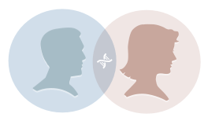

How are DNA Circles created?

https://www.ancestrycdn.com/dna/main/1.3.79/assets/images/evidence/help/help-topic3.png

What can DNA Circles do for me?

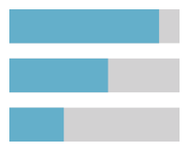

How are DNA Circle connection levels calculated?



How am I related to others in the DNA Circle?



Who will you see in a DNA Circle?



What is a New Ancestor Discovery?



How are close family members grouped together in DNA Circles?



How do DNA Circles change over time?



Why do DNA Circles only go back 6 generations?

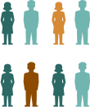

How do population changes affect DNA matching?



Why did AncestryDNA create DNA Circles?

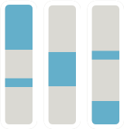

Do all members of a DNA Circle share the same matching segment?



How are shared ancestor hint confidence scores calculated?

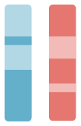

What is genetic inheritance?



Should other family members get tested?



DNA Circles White Paper