Ada Morgan McGuire
Born: 22 May 1910 –Senath, Dunklin, Missouri, United States
Married: December 22, 1928, Osceola, Mississippi, Arkansas, United States to Ada Morgan
Death: 17 June 1979, Renton, King, Washington, United States – Prostate Cancer
Ada Morgan was the 6th of 10 children born to Joseph Charles Samuel Morgan and Mary Melinda Clark, aka Mamie.
Grandma McGuire was almost 9 when her Dad passed away. She was 20 when her Mom passed away.
Grandma was close to her brother First, also known as Doc.
Grandma and Grandpa married on December 22, 1928. Her new Mother-in-Law was not happy about the marriage, but eventually learned to love Ada.
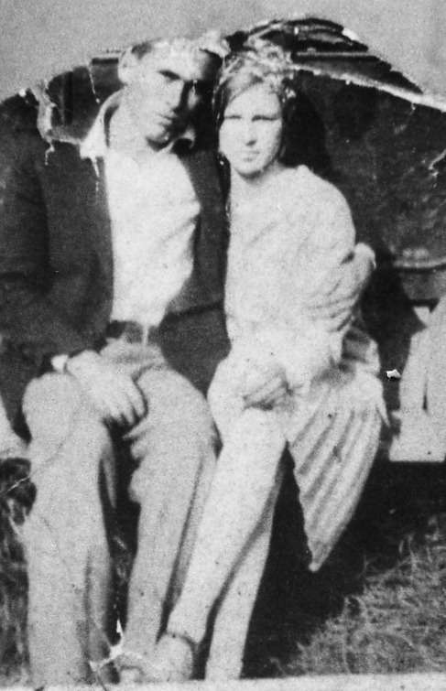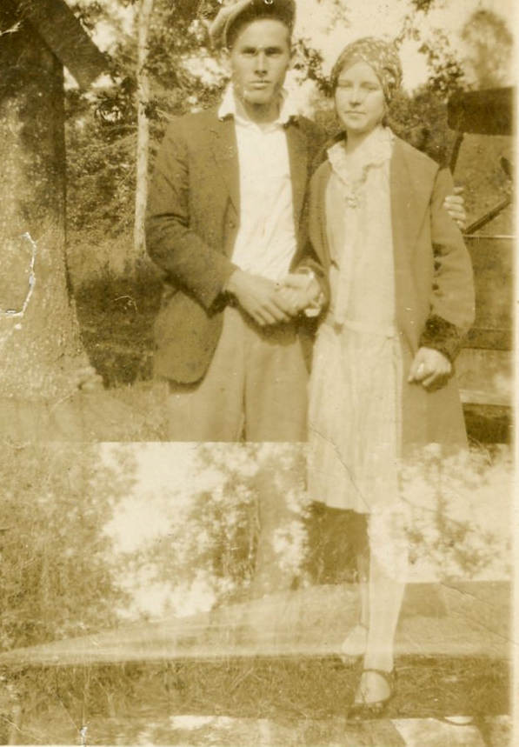

Grandma and Grandpa lost a child before their eldest, Virginia, was born. Mom never stated if this child was a boy or girl, if the child was full term, stillborn, etc, but that Grandma had been far enough along that Grandpa buried the infant.
When Grandma McGuire was 20 years old, her Mother, Mary “Mamie” Clark Morgan passed away on November 4, 1930. Grandma’s younger siblings lived with other siblings until they were grown.
Sometime before 1935 the McGuire and Morgan families travel to California. During their travels they would have to stop occasionally to work and earn enough money to continue their journey. This is where Uncle Doc got his nickname. He worked in the morgue at a Hospital.
When Grandma McGuire was pregnant with Uncle Harold, she was involved in a car accident. When Uncle Harold was born, a twin, that apparently died around the time of the accident, was also delivered. I do not know if this was a boy or girl, I am not sure they knew.
When Grandma was about 9 years old, she found $900.00. Her brother, Charles bought her a doll with the money, but he either kept the rest for himself, or hopefully, gave it to his Mother for the Family.
Uncle Doc also named Grandma as his beneficiary on his Military Life Insurance. Grandma never saw that money or his service awards. Grandma always had the picture of Uncle Doc on her living room wall. Grandma was working in the fields when my Mom received the telegram about Uncle Doc. Grandma collapsed from grief upon reading it.
Grandma used to use snuff. I always thought it was gross. She had a snuff bucket next to her chair. One time, before I knew what that bucket was, I stuck my fingers in it. Never again. At some point, Grandma gave up that habit, although she continued to smoke cigarettes. She was for a time an alcoholic and gained a lot of weight.
In 1965, Grandma suffered a heart attack. According to my Mom, this killed half her heart. Grandma lived another 14 years.
Grandma had a cat names Twinkles. I do not have a picture of that cat. Twinkles had to be in the mood for someone to pet her. I think that cat was over 20 years old when it was killed. Uncle Harold found her in the woods.
Grandma knitted/crochet my sisters and me the cutest little purses. I just love mine.
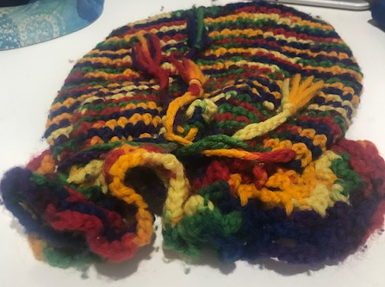

I also remember how excited I was to get a piece of mail from Grandma and Grandpa at Christmas in 1970, it was their picture.
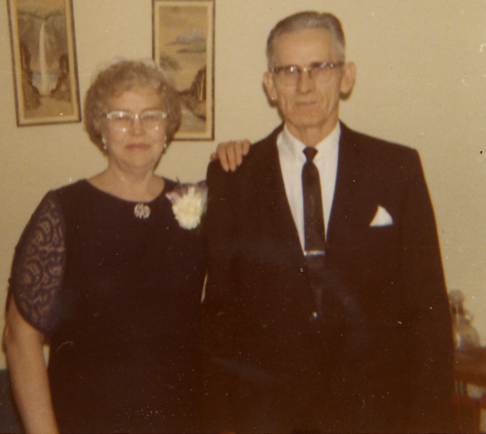
I remember that Grandma called almost every day. When I would answer the phone, I would hear her say “heellooo” all southern like, slow too. Whoever answered the phone would talk to her for a few minutes. I remember wanting not to talk to her because I was young and dumb. What I would not give to hear her voice now. Years later when I called Aunt Ella, Grandma’s sister, on her 90th birthday, I was brought to tears by how much Aunt Ella sounded like Grandma. It really brought back the memories.
Aunt Ella told me how after their Mother, Mamie, died, that the younger siblings were tossed around between the older married siblings. Aunt Ella said she was left Mamie’s bible, that had all kinds of information in it. Luckily, Aunt Effie wrote all that info down and mailed it to my Mom before she died. Aunt Ella said that Aunt Effie got mad at her, kicked her out of the house (she had to go live with Second and Mattie Morgan). Effie kept the bible. Years later when I asked Effie’s Granddaughter, Darlene Frasier, and Effie’s son-in-law, Paul, what happened to the Bible, they said Effie had destroyed it. From this Bible is how we knew that Joseph Morgan had been married to a M.H Key and had a son, J.S. My Mom told me that Mamie had been living with them taking care of them while they were sick.
To my knowledge, Grandma only flew on an airplane 2 times. Once was in the early 60s. She went to Michigan to see her Sister, Effie, Ella and Lillie were there too. And 2nd, Grandma and Grandpa went to Alaska to visit Aunt Pam.
l-r: Ella Morgan Bishop, Ada Morgan McGuire, Lillie Morgan Howard, Effie Morgan Frasier.
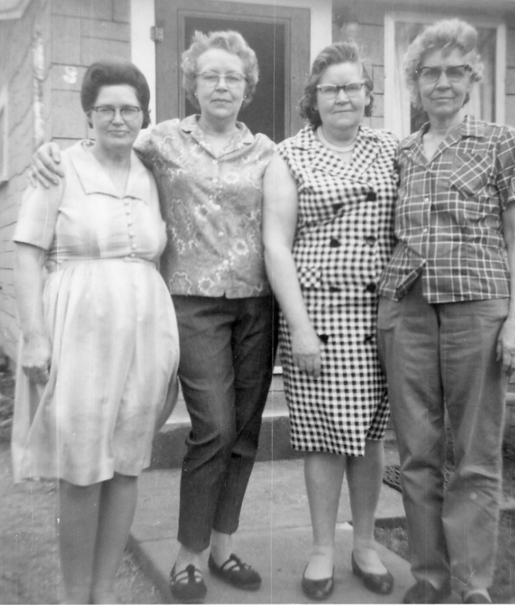
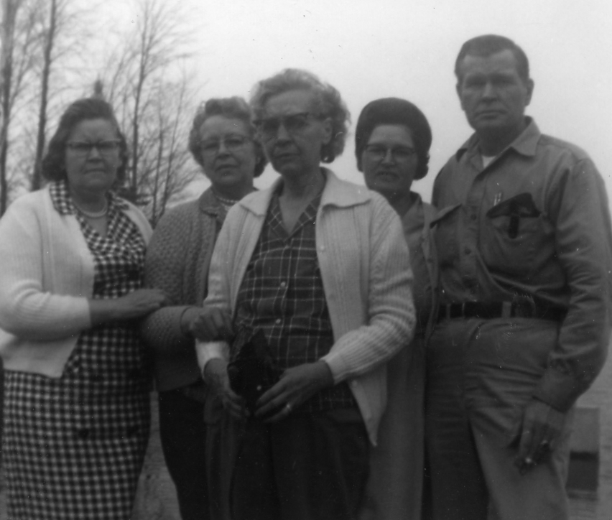
Jessie Morgan also was there.
Grandma wrote about her life. I have attached those pages to the end of this document.
Grandma helped Aunt Mina with her children, and she loved to watch Billy Graham. I can still see Grandma and Grandpa sitting in their chairs watching TV.
I remember one Christmas we dropped off our presents to them, in the car, on the way home, Mom said that Grandma would open every one of them and then re-wrap them because she cannot stand to wait.
I imagine Christmas when Grandma was a child. is nothing like it is today, or then in the 70s.
Grandma loved Ham. The worse thing she could eat with a bad heart. But she thought because it was not Red meat, she was ok. I remember always had to have Ham on special occasions.
My Brothers, Les and Randy, remember visiting with Grandma and Grandpa, and when it was time to fix dinner, Grandma would grab a chicken and, with an axe, cut its head off and let it run all around the yard. I had to look that up to see if it was possible because I did not believe it. Well, it is true. Yuk. Anyway, then she would boil it and pluck the feathers out. Yuk.
Grandpa McGuire built at least 3 homes that we know of. The 1st, my Mother, Virginia Louise McGuire was born in on April 30, 1930 and my Uncle Lucky on April 27,1934. In between these 2 children, they moved to California for a brief time. This is where my Uncle, Joseph Delano, J.D. McGuire was born on September 21, 1931.

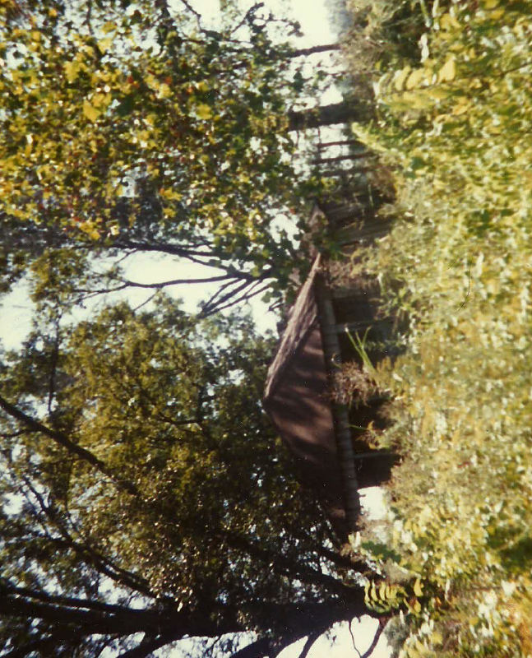

This one was in 1942/1943 in California.
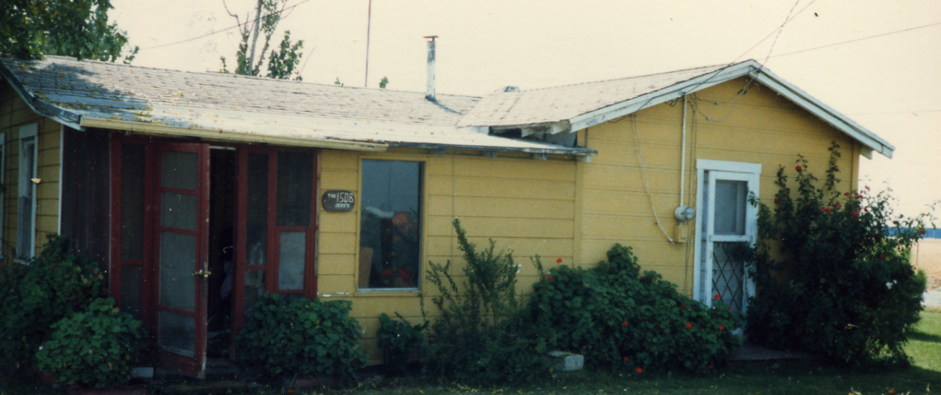
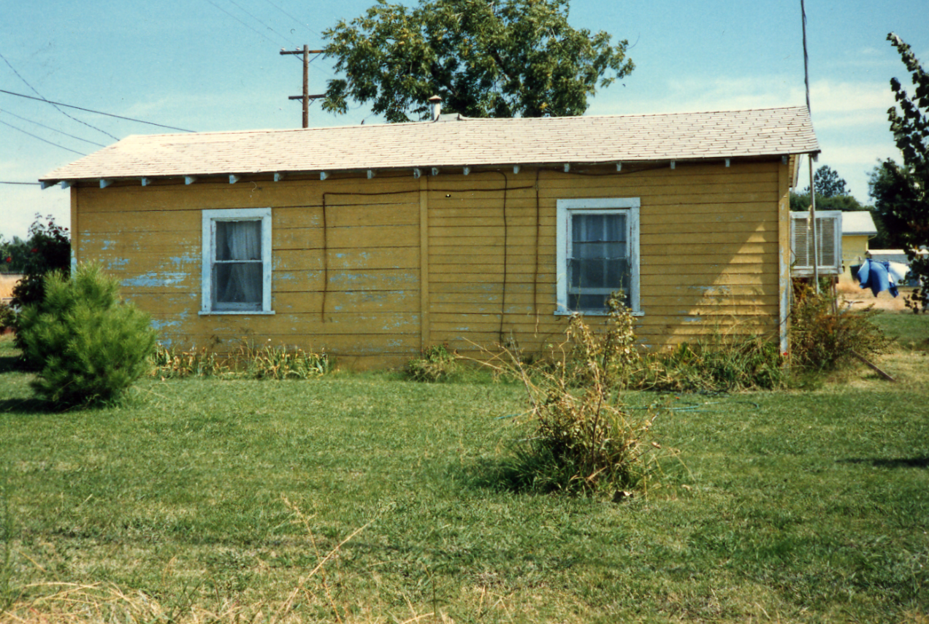

And their last home at 30031 164th Ave SE, Kent Washington , where many family gatherings were held. (looking for a good picture of this home) this picture below was taken at Grandpa’s retirement party.

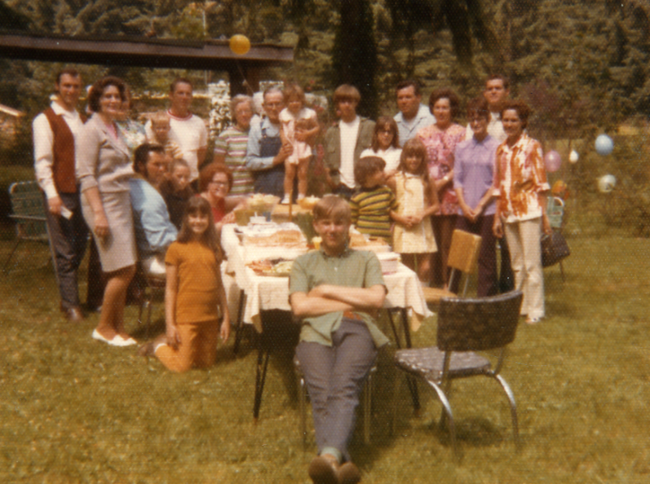

In August of 1955, Terrell and Virginia Rogers, who were living in Renton Washington at the time, went on vacation to California to see both their parents. When they arrived at the McGuire home, everything was packed up and they were heading to Washington. So much for vacation, the family all returned to Washington.

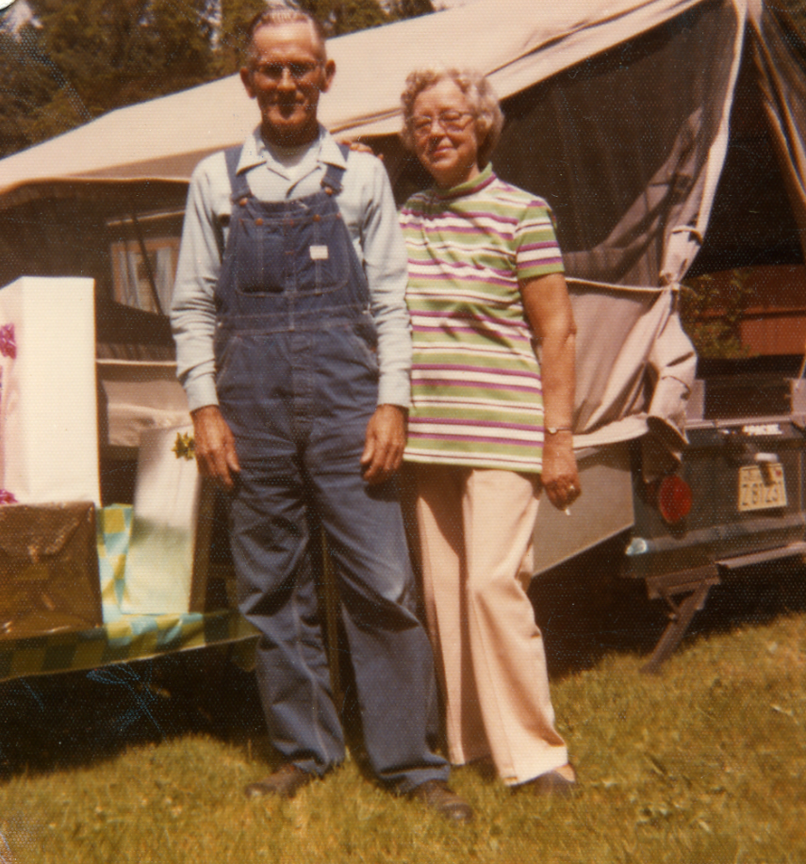
They owned a light blue car and went on vacation to see his family in Modesto California. Somehow they ended up taking a wrong turn and ended up in a parade. Grandma just waved. I can just imagine what that was like and I bet Grandpa chuckled.
I remember Grandpa and Grandma would come down most Saturdays when they would do their shopping. I never had the opportunity to spend the night at their house, but my older siblings did.
Grandpa always called my Mom “Sis” and Grandma called her “Sister” I think that is probably why Mom’s brothers always called her “Sis”.
On December 22, 1978, Grandpa and Grandma celebrated their 50th, and last, in this life, Wedding Anniversary at the home of Virginia and Terrell Rogers.
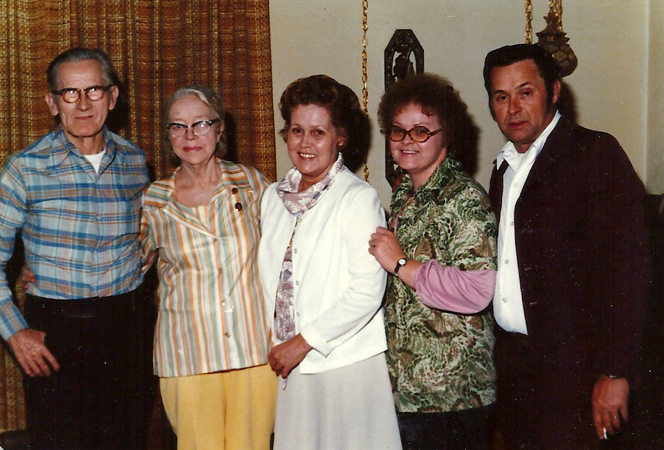
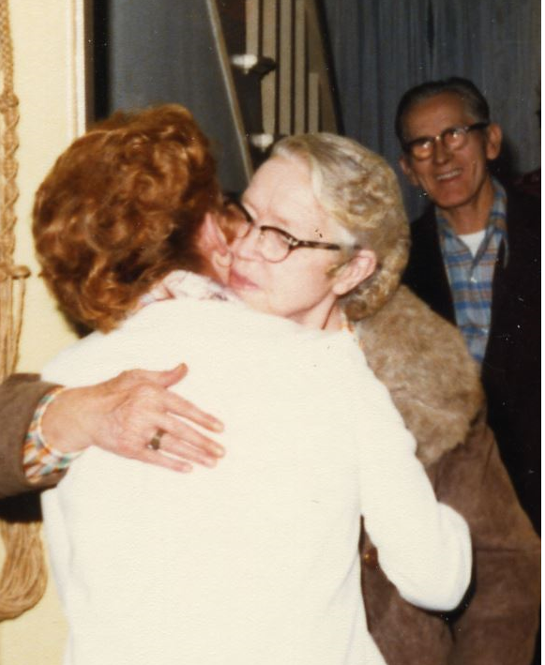

On June 14, 1979 Grandma Ada Morgan McGuire had a heart attack. I was at our Church practicing for a performance with my brothers, Les, Randy and Noel. Noel left because he had to get up early for work. Not long after he left, I had this horrible feeling that something was wrong. I assumed it was Noel. I called home and Sheri told me he was home and in bed. The feeling didn’t go away. Randy took me home that night and when we got to the door, Sheri opened it and said, “Grandma’s had a heart attack”.
The ambulance had to stop at least 1 time on the way to the Hospital to resuscitate Grandma. At the Hospital when asked how she was, she said she was going to beat on that young man’s chest and see how he likes it. She asked to see Uncle Harold and Fawn. She was especially close to Fawn and Fawn was due that Summer with Aaron (born 7/4/1979). Fawn stated that Grandma was always excited about her pregnancies but this one with Aaron was different. Fawn felt that Grandma knew she would not live to see the birth.
She lingered until Sunday, June 17, 1979 and went home. Grandpa and Grandma never attended Church, as far as I know, but she loved Billy Graham and I believe that she believed in our Heavenly Father and Elder Brother, Jesus. I remember thinking, she was 9 when her Father passed away, and she was 20 when her Mom passed away, what a reunion that was for her. I know in my heart that both Grandpa and Grandma have accepted the Gospel.
Grandpa McGuire and my Mom, Virginia Louise McGuire Rogers, at Hill Crest Burial Park, Kent, King, Washington, a few days after the funeral for Ada Morgan McGuire.
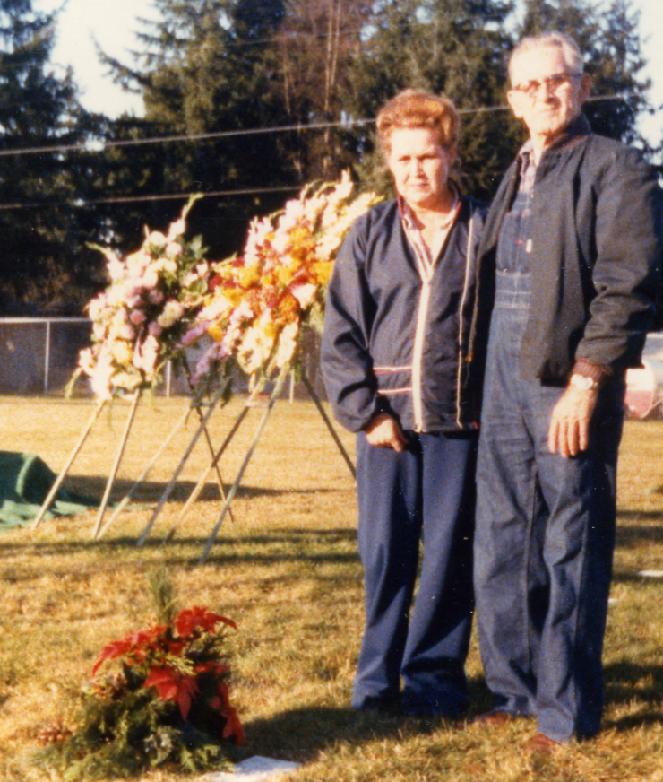
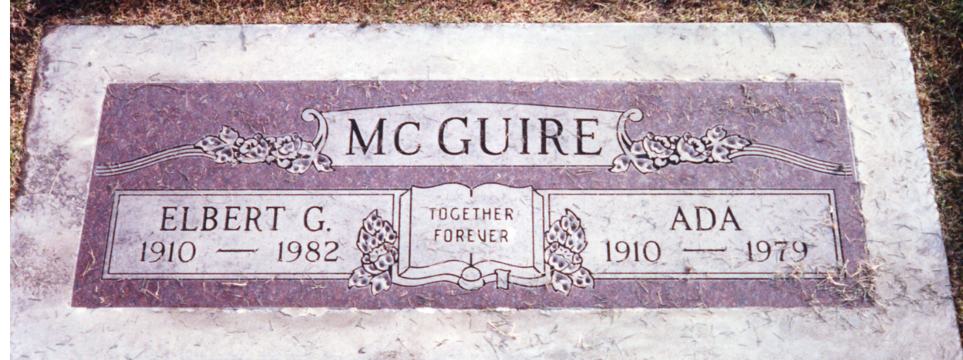

Joellen (Jodi) Rogers Johnson – Granddaughter of Ada Morgan McGuire

